

217, Sheikh Rashid Building

P.O Box 56272, Dubai

United Arab Emirates

Tel: +971 4 2973236 / 04 2974007

Email: uae@verbat.com

PROJECT   
PROPOSAL

**Reality Based Training Management System**

|  |  |
| --- | --- |
| **Prepared for:**  Elite Tactical For Military Consultancy & Training LLC  **Sinoj Kurain**  Finance - Accounts Payable  United Arab Emirates | **Submission Date:**  06 March 2017  **Proposal ID:** SW/12122016/1245/1 |

___________________________________________________________________________________________________________________________________________  
Conﬁdentiality Notice: This Proposal is conﬁdential and contains proprietary information and intellectual property of Verbanet Technologies LLC. Neither this proposal nor any of the information contained herein may be reproduced or disclosed under any circumstances without the express written permission of Verbanet.

© 2017 by Verbanet Technologies LLC. All rights reserved. Confidential.

___________________________________________________________________________________________________________________________________________

Project Contacts

|  |  |
| --- | --- |
| Client Information | |
| Project Name | Reality Based Training Management System |
| Client Name | Elite Tactical For Military Consultancy & Training LLC. |
| Client Address |  |
| Phone Number |  |
| Contact Person |  |
| Contact Person Email |  |
| Contact Person Phone Number |  |
| Contact Person Fax Number |  |
| Verbat Information | |
| Contact Person | Ms. Joyce Daniel |
| Contact Person Phone Number | 04 2973236 |
| Contact Person E-Mail | Joyce.daniel@verbat.com |
| Address | PO Box 56272, Dubai |
| Physical Address | Flat 217, Sheik Rasheed Building, Hor Al Anz East, Dubai |
| Project Information | |
| Proposed Technology/Methodology | - |
| Anticipate Start Date | NA |
| Proposal Valid For | 30 Calendar days from the submission of the proposal |

**Table of Content**

1 Executive Summary 6

1.1 Solution Objective 6

1.2 Advantages of Proposed Solution 11

1.3 Why Verbat 11

1.4 Key Differentiators 12

1.5 Underlying Support Services 13

2 Functional Specification 14

2.1 Phase 1 14

2.1.1 Admin (organizational setup) 14

2.1.2 Management Dashboard 14

2.1.3 Trainee 15

2.1.4 Trainer 15

2.1.5 Attendance Management 15

2.1.6 Training Management 15

2.1.7 Trainee Health records management 15

2.1.8 Video Management 16

2.2 Phase 2 16

2.2.1 Wireless Heart Beat Monitor 16

2.2.2 Starting and Stopping Cameras 17

2.2.3 Finger print scanner to mark trainee attendance 18

2.3 Phase 3 18

2.3.1 Integration and fine tuning of hardware components 18

2.3.2 Information Management & Reporting 18

3 Solution Concept 20

4 Functional Architecture 21

5 Hardware Architecture 23

6 Assumptions 23

7 Out of Scope 24

8 Technology Solution 25

8.1 Technical Configuration 25

8.1.1 Development Tools 25

8.1.2 Browser Compatibility for Web Admin 25

8.1.3 Hardware Interface 26

9 Delivery Management 27

9.1 Project Management 27

9.2 Roles and Responsibilities 27

9.3 Phase Delivery Activity summary 28

9.4 Project Implementation plan 28

9.5 Deliverables 28

9.6 Release Planning 29

9.7 Risk and Contingency planning 29

10 Change Management 31

11 Project Effort & Timeline 32

11.1 Effort Estimate 32

11.2 Delivery TimeLine 32

12 Commercial overview 33

13 Miscellaneous 34

13.1 Warranty 34

13.2 Acceptance Criteria 34

13.3 General Terms and Conditions 34

13.4 Assumptions and Dependencies 35

13.5 Source Code & Intellectual Property Rights 35

14 Our Clients 37

# Executive Summary

Elite Tactical (here after referred to as “Client”), founded in 2008 is an innovative Reality Based Training (RBT) provider in the Middle East specializes in a broad spectrum of military & law enforcement training in defensive and combative military procedures. The client would like to develop an application that can be used for a Reality Based Training Management (RBTM). The application shall track training sessions along with scenarios associated with the session. Sessions shall be linked to trainers and their trainees’, track equipment’s and weapons used by the trainees as well as record the performance of the trainees. The application shall generate various reports that support executive decision making. Verbat shall provide services to develop the application, provide operations and management support, hardware and in-house hosting during the development and implementation phase.

Application Development is an area where Verbat has in-depth knowledge and expertise. Being the pioneers in Web based and windows based solutions across the major verticals, we are sure to help you enhance your customer engagement to drive differentiation. We bring proven methodologies and processes, global expertise in application development, and a legacy of best practices and ready-to-fit frameworks to expedite the development cycle and reduce the total cost of ownership.

Verbat is pleased to have received the request to submit the proposal and values it as a great opportunity to have a long term & mutually beneficial association with the client. Verbat has gone through the requirement and presents a technical proposal for the requested system. With the focus of delivering value to client, Verbat proposes a managed solution model for this requirement.

## Solution Objective

The client has contacted Verbat Technologies to develop a Reality Based Training Management System. Verbat will advise the client on the solution requirement, selection of technology, hardware & software requirement, server configuration & security. Verbat shall be in charge of the complete turnkey operations of the training management system. The scope of the system includes

* Study, Design, Development & implementation of RBTMS
* QA & UAT
* Security Audit of the system
* On premises hosting of the software or any other datacenter chosen by Elite
* Onsite training and handholding of the project
* Application documentation (Wireframes, Requirements, Specifications & Test Cases)
* Post launch application maintenance, enhancement, user support & training

.

**The main features of the application are listed below**

* Admin (organizational setup)
* Create Scenarios, Sessions, Scheduling Sessions
* Create Schedules,
* Equipment’s, weapons, trainers
* Attendance monitoring, timesheet
* Trainers, Trainees
* Training room and camera registration
* Configuration for pulse monitors
* Configuration for IP Cameras
* Configuration for Finger print scanners
* Management Dashboard
* Ongoing training session status
* Completed training sessions
* Individual Trainee reports
* Progress report for trainee, sessions, trainers, scenarios
* Trainee
* Trainee profile
* Trainee Performance evaluation (heartbeat & scenario scores)
* Performance report
* Trainer
* Update profile information of self
* Create scenarios & tasks
* Update timesheet and availability
* Maintain trainee records on performance
* Trainee attendance
* Hardware configurations
* Configure & integrate the camera feeds into the software being developed, so that the feeds can be retrieved on demand
* Configure and integrate the finger print scanner to record attendance
* Configure and integrate the heart beat monitor
* Attendance Management
* Mark leaves for trainees
* Automatic re-scheduling of training sessions for absentees
* Calculate leave balance & classes to be completed
* Email alerts for attendances and scheduled classes
* Training Management
* Training sessions with scenarios
* Record activity of each trainee per scenario
* Record performance (heartbeats and scores)
* Trainee Health records management
* Real time monitoring and alerts for heartbeats if heart beat goes beyond specified range (heartbeat before, during & after scenario)
* Record peak heartbeats
* Video Management
* Establish video naming convention and storage location
* Link videos to scenarios, locations, trainees & trainers
* Identify videos by angle, channels and feeds
* Archive old videos for up to 5 years
* Information Management & Reporting
* Graphical and numerical reports related to
* Status of training sessions
* Completed training sessions
* Scheduled sessions
* Cancelled/postponed sessions
* Attendance
* Trainee progress
* Training Session reporting on
* Participant list and details
* Absentee list and rescheduled dates
* Instructor details and performance
* Scenario wise reports
* Trainees Individual report
* Complete history of the trainee
* Session wise and scenario wise performance of trainee
* Heart rate and body vitals of trainee
* Notes/remarks by trainers
* Comparative analysis of trainees’ performance scenario wise
* Graphical representation of trainee performance
* Trainee’s overall report
* Report of all trainees in a batch
* Report on high performing trainees and low performing trainees
* Comparative report on heartbeats in a batch
* Attendance report
* Graphical representation of the performance improvement of a batch
* Training deadline & remaining sessions graph
* Login statistics
* Instructor’s report
* Session completion details
* Number of students trained
* Scenarios completed
* Leave reports
* Overall progress
* Scenario wise reporting
* Total sessions trained
* Instructors details
* Login statistics

Verbat’s Solution architects have conducted a thorough research on the requirements and have come to the conclusion that our proposed solution, which is detailed further in this document, will meet the requirements put forth by the client. And the proposed solution will be delivered in a phased approach as per Verbat‘s managed solution model.

**Strong and Scalable platform:** The platform proposed will be strong and scalable enough to accommodate future enhancements such as scheduling, auditing & logging, push notifications etc.

**Accelerated solution:** The framework would act as a solution accelerator. It would provide the basic building blocks which could be reused in future for building new components and features as part of enhancements

**High performance:** The light weight framework used consumes fewer system resources thereby making the application perform faster

* System shall be available 24/7
* System shall be performant without any lags or delays
* System should be accessible by up to 15 people at a time
* System Shall be able to store up to 10,000 soldier details at a time

**Security:** The application will be developed considering various aspects of security.

* Database Server shall be housed in a secure location, either on the company’s premises. There shall not be an option for cloud hosting
* System shall work on the companies LAN/WAN without the need for an internet connection (Intranet application)
* Only authorized laptops and tablets shall access the application
* Only authorized personnel shall have access to the system
* Encryption shall be used to secure sensitive information
* Video feeds shall be encrypted and stored

## Advantages of Proposed Solution



01

Agile development offering reliable, scalable and secure solution

02

Smooth transition and quicker completion of processes

03

User friendly interfaces enabling easy navigation between screens

## Why Verbat

Globally Accredited

Software Consultation Partner

Spearheaded by a   
team of Technology and   
Management Leaders



Over 16+ years of customer experience with Global   
Corporations

Service in Banking, Retail, Logistics, Construction & Contracting, Fashion, Manufacturing, Hospitality, Automotive, Healthcare and Government sectors

IT Strategy, Application Development and Maintenance, Testing Services, Information Management and Digital Marketing efforts



## Key Differentiators

Delivered digital transformation expertise to global customers for over a decade by following industry best practices to maximize ROI for client

Keen technology intelligence combined with aggressive market research to deliver solutions that achieve results with measurable value

Enable access to global consulting expertise with strong local market and business knowledge

Commercial Model that is customizable for your business needs

Reuse of code libraries for Rapid Application Development

1,000,000 plus man-hours of expertise in technology frameworks spanning Microsoft, Open Source, mobility platforms and other proprietary IT technology

Partners top technology vendors to bring in the latest and best services in integration, collaboration, and development

Commercial Model that is customizable for your business needs

Proven Methodologies & Processes

Investment in R & D

Strong Local Presence

Flexible commercial Models

Technology Associations

Code Repository

Software Development Experience

Offshore Development Centre

## Underlying Support Services

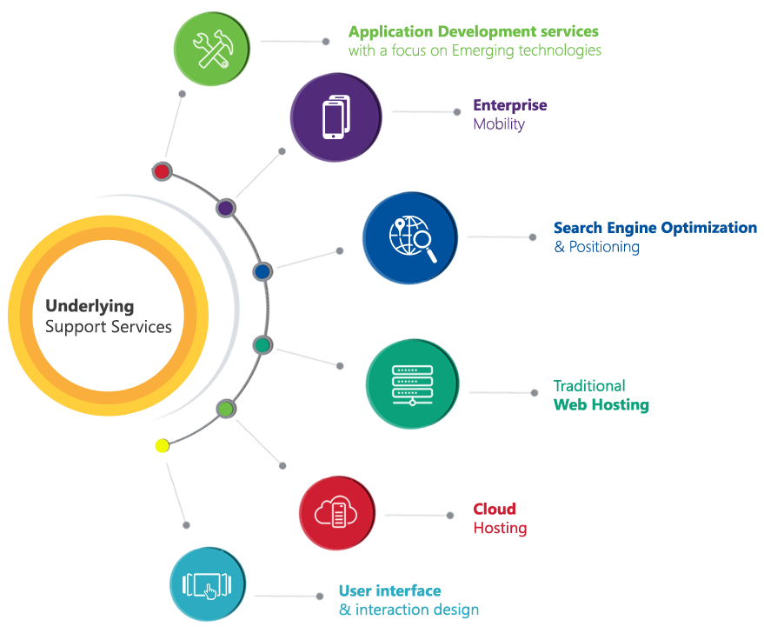

# Functional Specification

To develop the reality based training management solution, Verbat proposes that the application be **developed in three phases**. A complete solution to the proposed project requires integration of software application with hardware devices as well as tertiary services related to failover, performance and security

## Phase 1

In Phase one Verbat will develop the software aspects of the solution with focus in the areas mentioned below

### Admin (organizational setup)

* Create Scenarios, Sessions, Scheduling Sessions
* Create Schedules for sessions
* Add Equipment’s, Weapons and Trainers
* Create an Attendance schedule , timesheet
* Training area, trainers, trainees
* Training room and camera registration
* Configuration for pulse monitors
* Configuration for IP Cameras
* Configuration for Finger print scanners

### Management Dashboard

* Ongoing training session status
* Completed training sessions
* Individual Trainee reports
* Progress report for trainee, sessions, trainers, scenarios

### Trainee

* Trainee profile
* Trainee Performance evaluation (heartbeat & scenario scores)
* Performance report

### Trainer

* Update profile information of self
* Create scenarios & tasks
* Update timesheet and availability
* Maintain trainee records on performance
* Trainee attendance

### Attendance Management

* Mark leaves for trainees
* Automatic re-scheduling of training sessions for absentees
* Calculate leave balance & classes to be completed
* Email alerts for attendances and scheduled classes

### Training Management

* Training sessions with scenarios
* Record activity of each trainee per scenario
* Record performance (heartbeats and scores)

### Trainee Health records management

* Real time monitoring and alerts for heartbeats if heart beat goes beyond specified range (heartbeat before, during & after scenario)
* Record peak heartbeats

### Video Management

* Establish video naming convention and storage location
* Link videos to scenarios, locations, trainees & trainers
* Identify videos by angle, channels and feeds
* Archive old videos for up to 5 years

## Phase 2

Phase 2 activity can start simultaneously with Phase 1 activity.

### Wireless Heart Beat Monitor

**Hardware configuration**

Heartbeat monitors available in the market today require it to be connected via a serial port in order read the measurements of the heart monitor. Verbat proposes the development of an IOT based heart rate monitor which can transmit signals wirelessly. The device consist of an Arduino bread board hooked on to an Easy Pulse 1.1. The measured pulse shall be transmitted via an esp8266 multifunction wireless transmitter. The device calls a web service located on a local server (preferably within 500 m). The device can be fitted on to the trainees arm. Since each device has a distinct signature, the application will be able to uniquely identify the heartbeat of each soldier.

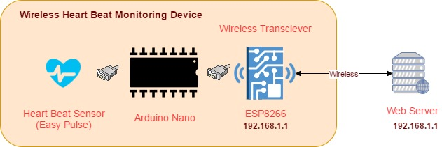

Arduino is an open-source electronics prototyping platform based on flexible, easy-to-use hardware and software. It's intended for designers interested in creating interactive objects or environments. Arduino can sense the environment by receiving input from a variety of sensors and can affect its surroundings by controlling lights, motors, and other actuators.

**Software Configuration**

The microcontroller on the board is programmed using the Arduino programming language (based on Wiring) and the Arduino development environment (based on Processing).

Software needs to be written and flashed onto the microprocessor to help it read the heart beats.

### Starting and Stopping Cameras

The requirements state that the cameras shall be started and stopped at the beginning and end of each training session. Further clarification stated that the client employs IP based cameras that stream live videos using the RTSP protocol. Verbat shall capture these live feeds and store them so that they can be retrieved later on demand.

In keeping with the spirit of automation, Verbat proposes a complete solution that can adhere to the requirements stated in the requirement document supplied by the client. The requirement can be split into 2 steps

1. Starting and stopping cameras can be achieved by utilizing Speech Intend Recognition software. The API for which is available from Google (<https://console.api.ai>). The application will be trained to respond to cue words for starting and stopping the recording of the live streams. Cue words can be anything (For Ex. “Start recording”). Cue words help the software to determine what course of action needs to be taken in response to it.
2. Live streams from an IP camera streaming using RTSP protocol can be captured using FFMPEG a command-line tool that converts audio or video formats. It can capture and encode in real-time from various hardware and software sources such as a TV capture card.

**Software Configuration**

Using verbal cues from the Trainer, the Speech Intend Recognition software (which needs to be developed) translates the instruction to actionable command line executions that will record the feeds from all cameras live streaming from the training room. Because the command line (*Ex. $ ffmpeg -i input.mp4 output.avi*) can be scripted interactively to output the video stream to a Network Attached Storage (NAS) with a predetermined file name (using a pre-established naming convention), each file can be uniquely tracked back to the camera source & session from which it was obtained. During the organization setup the admin registers all the training rooms along with the IP Address of all the cameras present in the room.

### Finger print scanner to mark trainee attendance

There are many Commercial of the Shelf (COTS) solutions that can be used to scan the finger prints of the trainees attending the sessions. The results of the scan be outputted to a Network Attached Storage. A windows service running on the server will automatically log the attendance into the software being developed. This is because the service will actively monitor the finger print results using the API exposed by the IP Camera.

## Phase 3

Phase 2 development starts in tandem with the Phase 1 development. Phase 2 will continue well into Phase 3 as well. Phase 3 development is primarily concerned with fine tuning the integration of the hardware devices into the software application being developed. Phase 3 will also be used to develop various reports on the day to day management of the application as well as executive summary reports to understand the progress of training sessions.

### Integration and fine tuning of hardware components

* Start and stop Video feeds; Retrieve on demand and Archive videos
* Attendance registration
* Heart beat monitoring

### Information Management & Reporting

**Graphical and numerical reports related to**

* Status of training sessions
* Completed training sessions
* Scheduled sessions
* Cancelled/postponed sessions
* Attendance
* Trainee progress

#### **Training Session reporting on**

* Participant list and details
* Absentee list and rescheduled dates
* Instructor details and performance
* Scenario wise reports

#### **Trainees Individual report**

* Complete history of the trainee
* Session wise and scenario wise performance of trainee
* Heart rate and body vitals of trainee
* Notes/remarks by trainers
* Comparative analysis of trainees’ performance scenario wise
* Graphical representation of trainee performance

#### **Trainee’s overall report**

* Report of all trainees in a batch
* Report on high performing trainees and low performing trainees
* Comparative report on heartbeats in a batch
* Attendance report
* Graphical representation of the performance improvement of a batch
* Training deadline & remaining sessions graph
* Login statistics

#### **Instructor’s report**

* Session completion details
* Number of students trained
* Scenarios completed
* Leave reports
* Overall progress
* Scenario wise reporting
* Total sessions trained
* Instructors details
* Login statistics

# Solution Concept

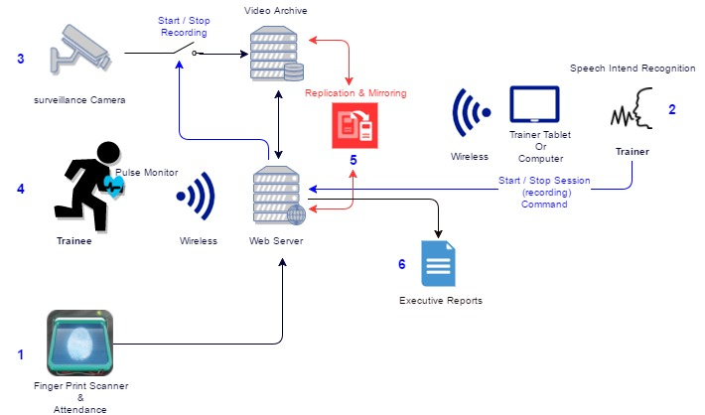

1. Trainees mark their attendance by scanning their finger prints on the finger print scanner. The results of the finger print scanner are propagated to the application. Absentees will be automatically rescheduled for future sessions.
2. The trainer starts the session by speaking “verbal cues”. The verbal cues are interpreted by the Speech Intend Recognition software and issues a command to record the streams for all the cameras present in the room
3. Although the cameras may be streaming continuously, only the video feed related to the sessions will be saved on NAS drives. This is because the instructor can start and stop the recording of the video feeds on demand
4. Trainees strapped with wireless heart rate monitors continuously emit their readings to a preconfigured service call. Service calls can be made bi-directionally depending on how the solution is implemented. Trainee’s heart rate can be monitored real time and any deviation from threshold levels would raise alerts on the trainer dashboard.
5. The system data will be mirrored and replicated on a daily basis using scheduled backup plans. Backups may be a file level or image level backup depending on the client’s preferences. The proposed plan’s primary objective is to protect the data from catastrophic hardware or software failures. The proposed backup plan is not a disaster recovery plan.
6. Various types of Executive and operational level reports shall be available to the trainers and management for checking the progress of training of a group or an individual person.

# Functional Architecture

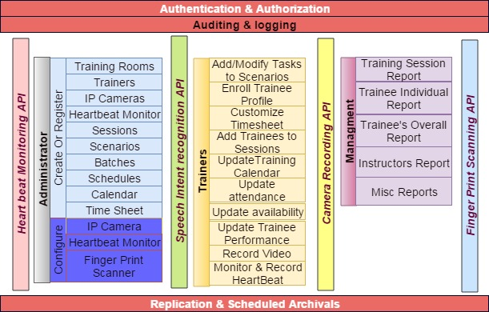

Functionally the application shall be split into 3 broad functional areas

**System Functions**

These are general purpose application wide functionality derived to provide

* Authentication and Authorization for security and privacy of personal data.
* Replication and archrivals’ for fault tolerance and data protection
* Auditing and logging to enhance security and to detect application failures to hardware or software errors

**Integration of Hardware Interfaces**

Integration of multiple hardware touchpoints demands the development of custom software applications or modules to communicate with them. System level programming is required to read the data from these devices. The devices that need to interface with the software application developed include

* Heartbeat monitor
* Finger print attendance management
* Voice intend recognition system to react to vocal cues
* Software to start and stop the video recording

**Application Software**

This would be the reality based training management system for which this proposal is being made. The application has 3 broad user groups namely

* **System administrators** who set up the organization. They are responsible for configuring the application so that it can be used by the trainers, trainees and management staff
* **Trainers** who set up scenarios, sessions, batches, classes and register trainees. Module also includes functionality for trainers for self-management (update profile, mark availability etc.) as well as monitoring and recording the performance of the trainees. Trainers can also generate reports to evaluate the performance of a trainee or the whole class
* **Executive Management** has access to interactive dash board reports that will give a summary view of the various activities under taken by the trainees, including their performance

# Hardware Architecture

# Assumptions

The project solution and technology is created from the initial understanding of the requirement shared with Verbat through mails and meetings. The proposed solution is based on the following assumptions;

* Color theme shall be provided by the client
* The client shall provide the branding guidelines
* Client shall provide licensed images and logos in specified size & format
* IP Cameras at the client facility shall have software interfaces
* IP cameras have a known IP address to source the video streams
* Files created by the IP Cameras have a known naming convention

# Out of Scope

With the ever evolving digital market, the requirement needs should be clear to both the parties involved, hence the importance of mentioning the out of scope details of the project. Following are considered to be out of scope while creating this proposal.

* Purchase of images, fonts
* Adding new features to the application other than mentioned in this proposal
* Any language other than English
* Manual data entry
* Database migration
* Content writing
* Hosting Infrastructure
* Annual Maintenance Contract ( Bug fixing, debugging, enhancements, develop new modules)
* Backup Solution and archival of video footage
* Physical deployment at client’s site
* Fault tolerance and recovery from crash
* Data Replication
* Software packaging and deployment

# Technology Solution

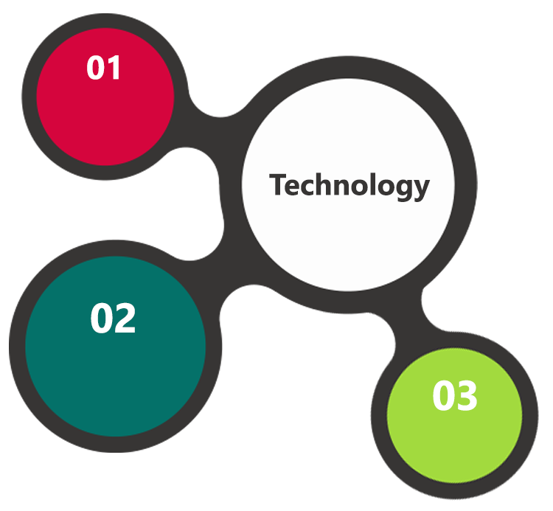

ASP.Net 4.5

MVC  
 Architecture

MS SQL 2014  
Windows 2012 OS  
IIS 8.0

HTML 5  
JavaScript  
CSS3

A major portion of the application will be developed using Microsoft technology employing a mix of web services, windows services, windows client software as well as web interfaces to configure the application.

Verbat will also be using install shield to package the windows based applications so that they can be easily deployed on to the computers

The Arduino microprocessor will make use of open source technologies such as Python and Linux to configure and program the devices

## Technical Configuration

### Development Tools

* Visual Studio
* MS SQL Server Management Studio & Photoshop
* Arduino Web developer
* Arduino 1.8.1 IDE, Arduino Development Kit

### Browser Compatibility for Web Admin

* Chrome 56.0
* Firefox 51.0
* Internet Explorer 11

### Hardware Interface

The application is reliant on hardware interfaces to provide a seamless automated user experience.

* Computer with Windows 8 or 10 OS
* Sensors/actuator nodes placed on human body to read heart beats
* Base stations to transmit the acquired heart beat reading
* WWAN / GPRS to transmit the data wirelessly
* Record streaming videos from IP based cameras
* API.AI from Google for Speech Intend recognition

# Delivery Management

## Project Management

The Verbat development center strictly follows industry standards on quality. The project management is process governed by the Verbat Quality Management system and is put to verification through internal audit programs that happen from time to time.

Verbat will dedicate a project manager for the proposed implementation. Verbat proposes Client to identify one project manager who will be driving activities to be undertaken by Client to be the single point of contact for Verbat.

## Roles and Responsibilities

Verbat will assign a dedicated Project Manager/Project Lead to lead the project, who will be the first point contact for Client. He/she will be responsible for planning and managing the various activities within the project. He/she will work closely with Client Project Manager, to give periodic status updates and ensure high level of visibility and comfort on the progress of the project.

The Project Manager/Project Lead will lead the co-ordination between Verbat and Client, thus enabling smooth transitioning of Client requirements to the Verbat’s offshore delivery team, and provide visibility as well as comfort on the progress of the services to Client.

He/she will have periodic meetings with Verbat’s Senior Management, thus ensuring Verbat’s Management commitment and focus on Client initiatives.

*Note: detailed qualification and experience of the persons involved in the project will be shared be finalizing the project on request*

## Phase Delivery Activity summary

|  |  |
| --- | --- |
| Activities | Description |
| Detailed requirement Analysis | Verbat team to conduct detailed study of requirement for the phase. If clarification is required, team will reach out to Client for more information and/or time for discussions. |
| Software Requirement Specification document (SRS) | Once the requirement analysis is completed, Verbat team will submit the SRS document for approval |
| UI/UX Design, Prototyping | Based on the SRS, Verbat UX/UI team will work on the UI/UX of the screens and submit a prototype for approval |
| Functional Specification Document (FS) | Once the Prototype. UI/UX is approved, Verbat shall submit an FS document for approval. |
| Development | Actual system development starts based on the FS. This involves detailed design and software development of Web Admin, API & iOS and Android mobile app. |
| Testing | Test Planning, test plan creations, internal, integration testing and user acceptance testing. |
| Deployment | Deploying the latest built in the Verbat Test Server. |

## Project Implementation plan

Verbat will be providing the solution in a phased approach which ensures minimum viable solution for quick wins with core focus on the long term business objective and outcome. Once the implementation of phase 1 is over, Verbat will initiate the application maintenance process which continues to extend after the implementation of successive phases.

## Deliverables

* Software Requirement Specification Document (SRS)
* Wire Frames for Key Screens
* Functional Specification Document (FS)
* Fully Developed & Tested Application
* Test Cases
* Fully commented source code
* User Manual (English)
* Install shield executable

## Release Planning

* Client will be informed about the release date and time through email.
* Client performs the UAT

## Risk and Contingency planning

Verbat has identified various risk factors associated with this assignment and understands the impact of these risk factors on the project schedules. The objective of this section is to highlight for both Verbat and client, the risk factors, to analyze the impact of the risks on project execution, and to propose strategies to control and reduce the impact of the risk factors.

These various risks, which could arise during the project, are tabulated below along with mitigation implementation.

| Type of risk | Impact | Risk Mitigation | Risk Handling |
| --- | --- | --- | --- |
| Scope Creep | H | Functions and features will be detailed in system requirement documents and will go through client approval. Once this document is approved, any change to requirement will go through change management review for possible impact assessment. | Proper change management procedure will be implemented. |
| Delay in customer feedback | H | The plan is prepared with enough lead-time for customer reviews and approvals.  The customer is indicated with the dates when the document is expected after review and approval. | The request for feedback will be escalated if not attended at the right time so that the schedules are not affected. Deemed acceptance criterion is set up front and will be followed. |
| Non-availability of necessary software’s, frameworks, database instances and infrastructure at client’s hosting environment(If hosting support is provided by Verbat) | M | Client will be informed in advance on these requirements. | Possible impact to schedule. |
| Manpower attrition | L | All efforts would be made to ensure process dependence rather than being person dependent. As a risk mitigation plan Verbat will train backups. | A new person will be identified as early as possible, provided the required project-specific training and mentored by the senior members of the team to minimise impact of attrition on the project. |

*H-High, M-Medium, L-Low, NA-Not Applicable*

# Change Management

Any addition which comes out of the project scope, upon and after the launch of the tool will be considered as change management. Verbat recommends the following change management procedure for the same.

* Any change which comes out of the project scope, which was discussed, documented, and mutually approved by both the parties in the requirement stage, will be carried out only through raising a change request.
* Change request will be studied and an impact analysis on the existing work flow will be performed.
* On finalizing the impact, effort estimation for the change will be calculated and raised as additional requirement.
* Verbat will initiate the change request only after getting a formal approval from the client for the additional changes raised.
* Any change from the scope will be charged at **AED 1200 per man day effort** and approval from the clients will be availed before commencing on any change management.

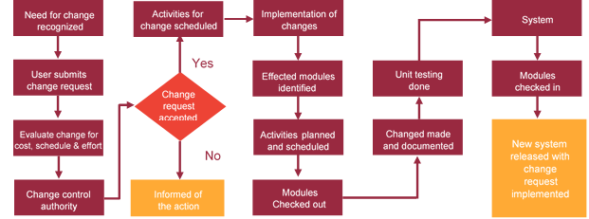

# Project Effort & Timeline

## Effort Estimate

The effort estimated for delivering the application as specified in this document will be as below:

|  |  |  |
| --- | --- | --- |
| **Activity** | **Effort (Man Days)** | |
| Initiation & Requirement Analysis | | 30 |
| Application Development | | 174 |
| Testing of the application | | 60 |
| Go Live | | 02 |
| **Total Man Days** | | **266** |

## Delivery TimeLine

|  |  |  |
| --- | --- | --- |
| **Activity** |  | **Delivery Days** |
| Development of the Reality Based Training Management System |  | 100 |
|  |  |  |

# Commercial overview

|  |  |  |
| --- | --- | --- |
| **Description** | | **Cost (USD)** |
| Development of the Reality Based Training Management System | USD XXX,XX.00 | |
| **Total** | | **$ X,XXXX.XX** |

* Easy Pulse V1.1 – INR 1500-2200
* Arduino Nano- INR 600
* ESP 8266- INR 1000
* Project Miniaturizing & packaging
* Finger print attendance system

# Miscellaneous

## Warranty

Verbat shall provide a bug ﬁx warranty at no additional cost for 30 days from the date of acceptance of the project, for correction of any errors in the developed application that may be attributed to Verbat.

However, this does not cover modifications by Client, or use of the application on an environment other than the proposed environment, or other circumstances outside Verbat’s reasonable control. In such a case Verbat reserves the right to charge for its services.

All error corrections will be executed at Verbat India office. In the event of any need for on-site work, all expenses incurred for such trips will be payable to Verbat by Client.

## Acceptance Criteria

* UAT sign off should happen within 14 Days from the release of each module/ Phase and the acceptance confirmation needs to be mailed to Verbat failing which Verbat will consider the project as approved by the client.
* Any comments or reason for rejection need to be documented and the same needs to be sent as an email from the official mail id of client to Verbat.

## General Terms and Conditions

* Offer Valid for 30 calendar days from the date of submission of the Proposal
* An average of 20 working days are assumed in a month
* This proposal and all technical/ functional specifications have been derived or concluded from the data shared via email / information's transferred during the initial requirement analysis meetings and conversations. Verbat reserves the right to amend the terms of this proposal, should the SOW terms, functional features and functionalities change during the course of the project
* The applications will be built as per the specifications agreed mutually. Any changes will be executed through a deﬁned change management process between both parties
* All Source Code and other project artefacts would adhere to the Verbat document templates and internal coding standards
* Acceptance criteria shall be based on the clauses which were mutually discussed between Verbat and client at the Requirement Analysis phase and the same will be documented and approved by both parties through official emails
* Final deployment to production server pursuant to completion of all payments

## Assumptions and Dependencies

* During the requirement gathering phase, authorized personnel from the Client’s side is expected to be available for discussion and finalizing the HLD (High Level Design), before development commences.
* Type of reports and formats, if under the scope of the project, needs to be specified by Client before project sign off.
* Workflows need to be specified/ confirmed by client before project signoff.
* All queries regarding the client requirement and any queries which may hinder the project advancement at any stage should be answered by the client within 24 hours from the time of initiation, failing which the time delay will get added to the actual effort which was estimated.
* Verbat assumes that all sign-offs from Client will be provided within agreed and specified timeframe.
* Client will provide all the necessary contents, both text and image, before starting the project in the format suggested by Verbat (if any).
* The client should provide the relevant information and data well in time for the execution of a related activity. Non- availability of this information or data may lead to an interruption of work which may result in a delay in delivery as well as additional costs to the client.

## Source Code & Intellectual Property Rights

* Upon completion of the Project and 100% completion of the payment, client will have access to the source code except for propriety codes, developer tools and third party application / modules like Microsoft Dynamics Products, Share Point LMS etc.
* The solution offered will be the intellectual property of the client and will be made available to the client on an “unlimited license” basis.
* Modifications by third party/person: No person or organization, other than Verbat or any person authorized by Verbat in writing, has any permission to modify/change the software Solution to be eligible to get continued support from Verbat as per the support terms defined under this document.
* Liabilities/Damages: Verbat accepts no liability or damages of any kind arising out of use or non-use of the software delivered. The responsibility of testing of software lies with Client.

# Our Clients

**UAE University**

Education

Transportation

**Canada Cartage**

Construction

Services

Finance

We look forward to hearing from you soon and hope that you will give us the privilege to work with you in meeting your business goals. Thank you.

Thank You



©   
1999 - 2017. All Rights Reserved   
Verbanet Technologies LLC  
www.verbat.com